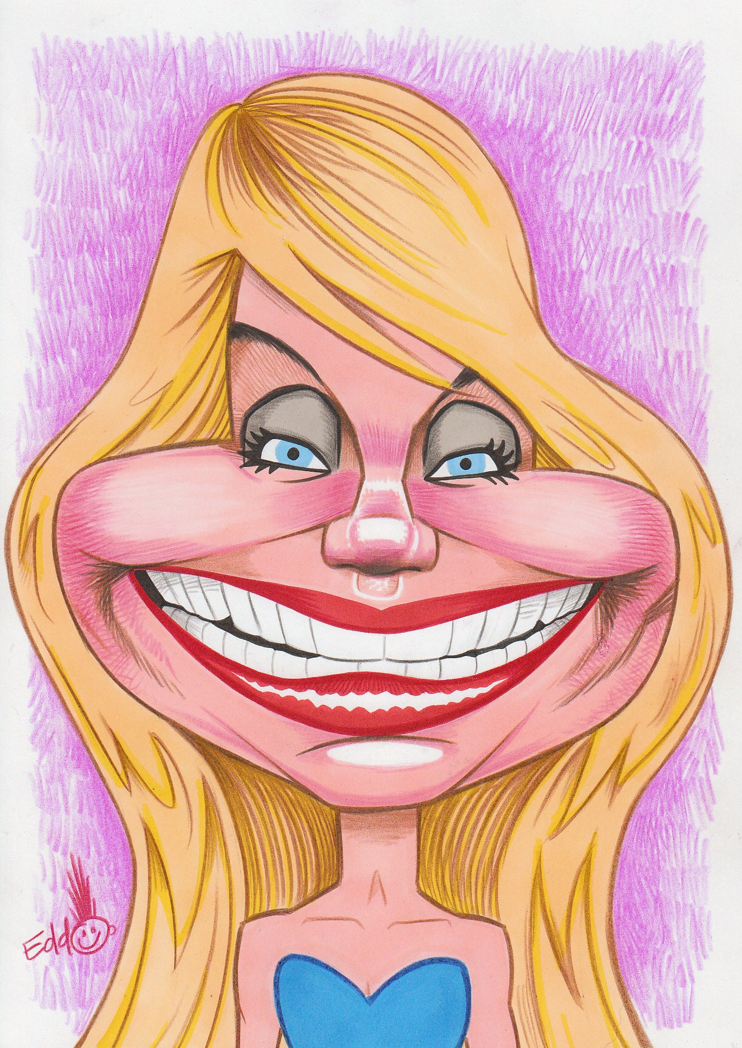
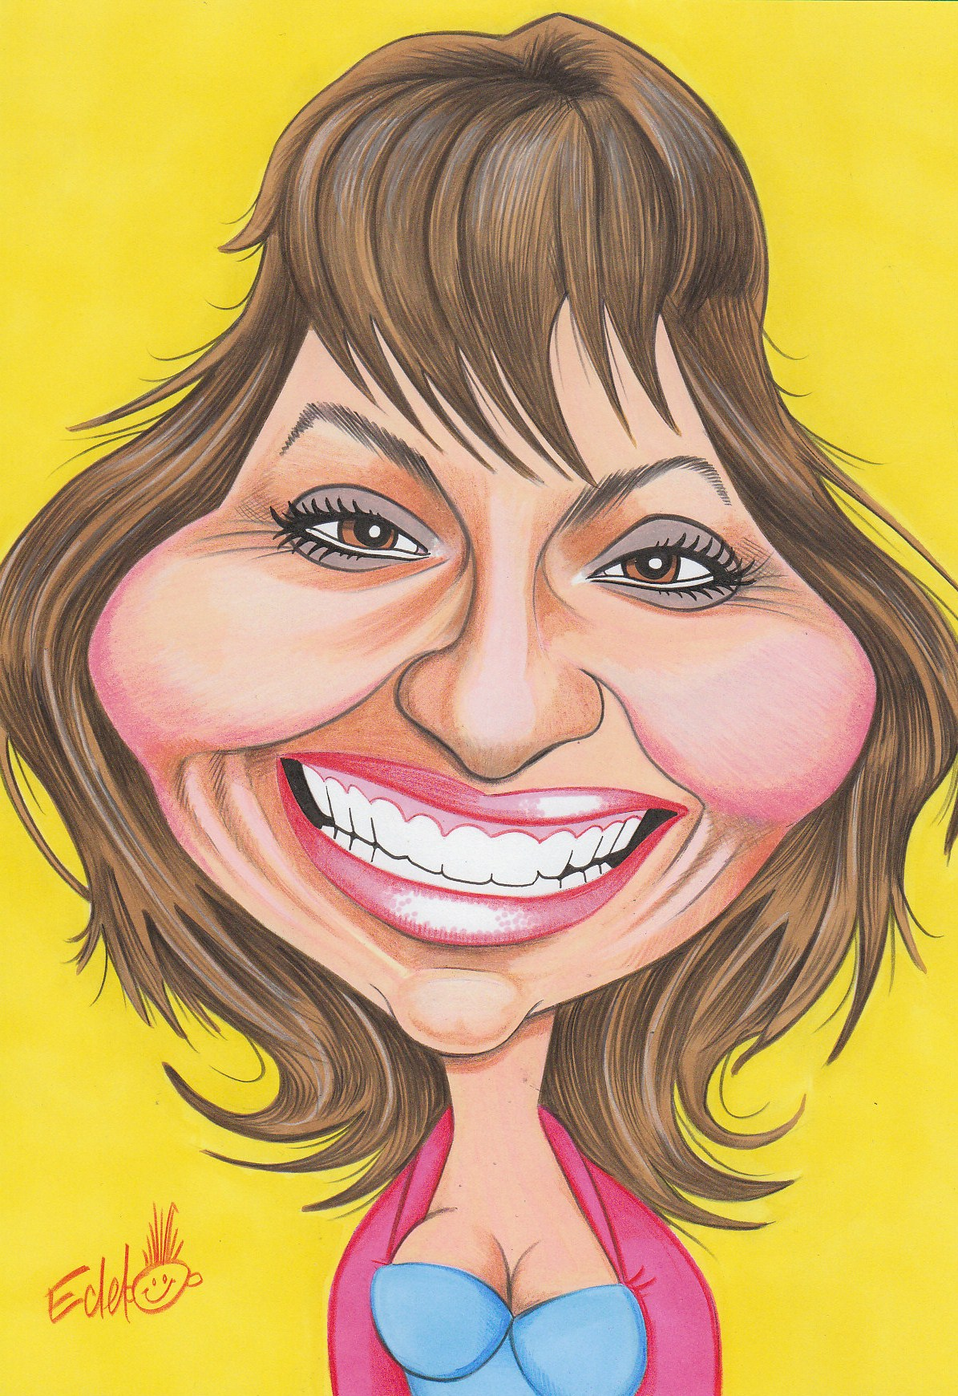
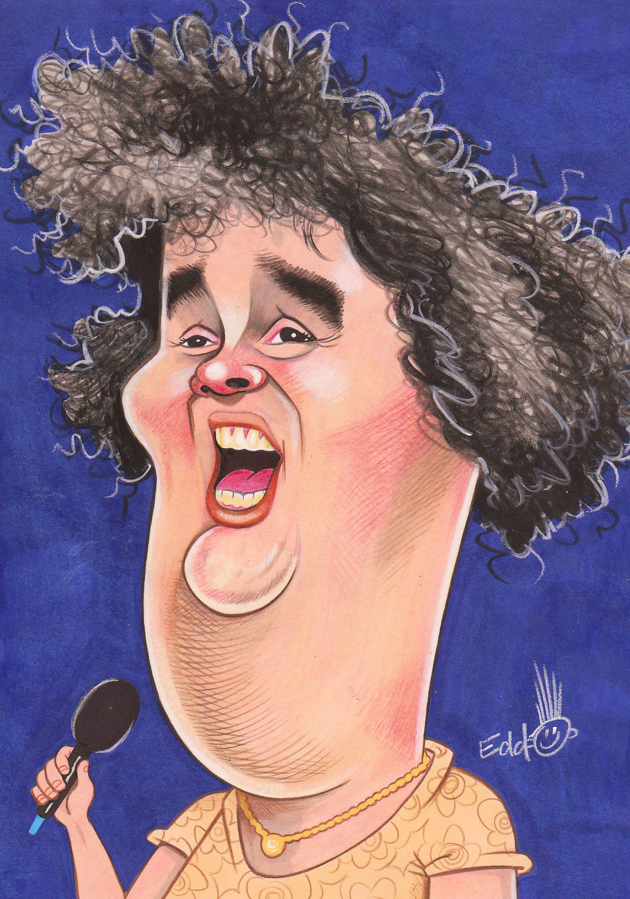
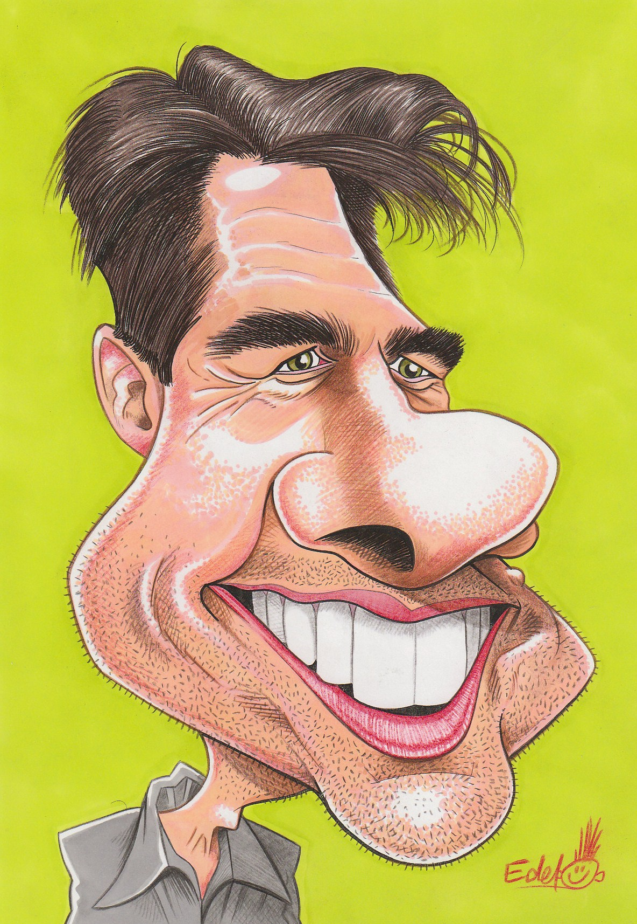
The Fab 50...
Edd’s Heads: Famous Faces Caricatured by Edd Travers
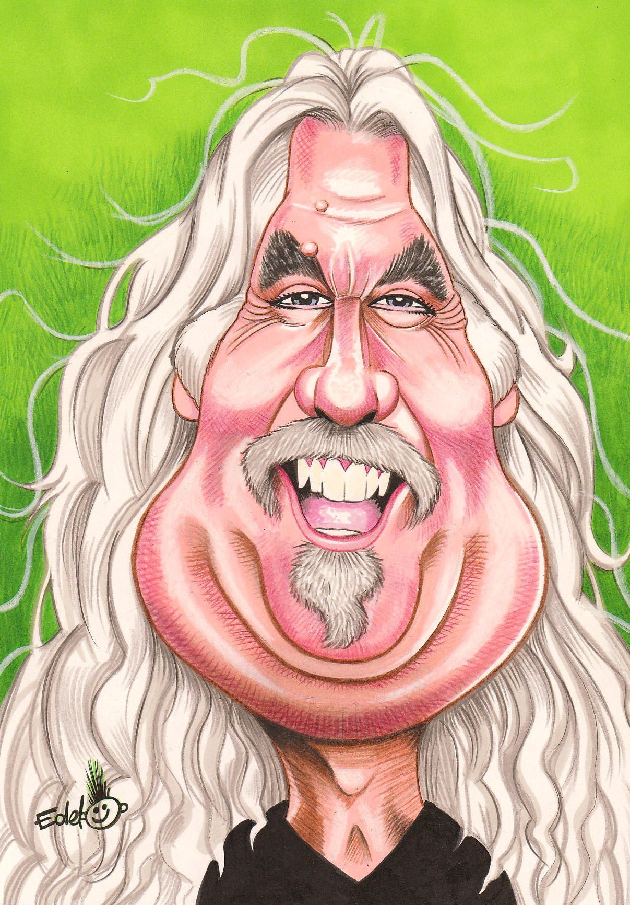
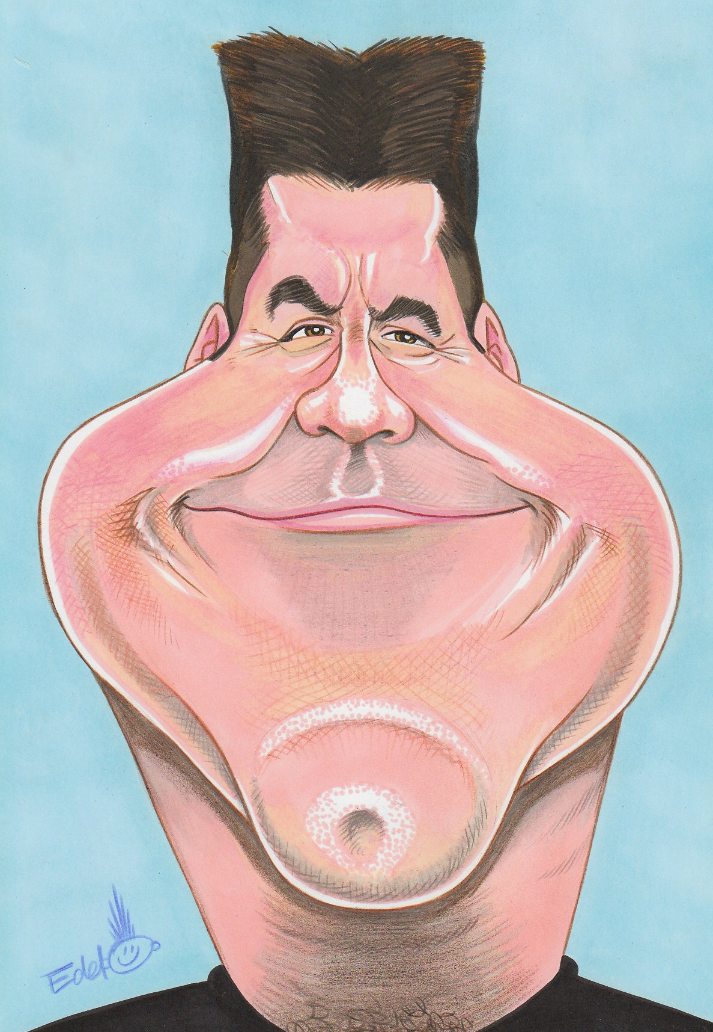
Come and check out the star portraits the celebs would rather you DIDN’T see, from Tom Cruise in all his ginormous-jawed glory to Simon Cowell looking more X-rated than X-Factor. Edd’s Heads is a hilarious new exhibition from one of Scotland’s leading caricaturists, Edd Travers. His 50 works feature some of our best-known faces, from home and abroad, poking fun at their fascinating features and showcasing the artists’ own expressive comic style. All have been created entirely by hand, with no digital enhancement.

The Fab 50 are:
Tom Cruise, Whoopi Goldberg, Tom Hanks, Morgan Freeman, Ricky Gervais, Brian Cox, Britney Spears, Nat King Cole, Sarah Jessica Parker, Cameron Diaz, Robert Pattinson, Susan Boyle, Barrack Obama, Tommy Burns, Kirsty Wark, Mick Jagger, Chic Young, James Corden, Ricky Tomlinson, Lorraine Kelly, Vic Reeves, Nick Cave, Gordon Ramsay, Morrissey, Simon Cowell, Robbie Coltrane, Alan Carr, Freddie Mercury, Jonathan Ross, Amy Winehouse, Gail Porter, Ken Stott, Daniel Craig, Rihanna, Shaun Ryder, Keith Richards, Sir Sean Connery, Stephen Fry, Leona Lewis, James Brown, Christine Bleakley, Frankie Boyle, Robbie Williams, Matt Smith (Doctor Who), John Lydon, Jimi Hendrix, Billy Connolly, The Pope, Michael Jackson and Clint Eastwood.

DATES FOR YOUR DIARY:
Exhibition runs from October 9 - November 6, 2010 at The Auld Kirk Museum, Cowgate, Kirkintilloch, near Glasgow, tel: 0141 578 0144. Opening times: Tuesday-Saturday, 10.00am-1.00pm & 2.00pm-5.00pm. Admission Free. Edd will be dropping into the exhibition on each Saturday. On Saturday October 16 he will lead a caricature workshop for children as part of The Big Draw Campaign (10am-1pm and 2pm-4pm).

ABOUT THE ARTIST:
Edd left Glasgow College of Building and Printing with an HND in illustration in 1997 and has since become recognised as one of Scotland’s leading caricaturists.
His celebrity caricature work was previously exhibited at the National Portrait Gallery in Edinburgh. Many of the celebrity subjects contacted the artist personally to show their sense of humour and express their appreciation.
Much of the work at his first solo exhibition, Edd’s Heads, is brand new and previously unseen.
As well as exhibiting his work, Edd travels all over the country doing live caricatures at weddings, parties and events as well as producing gift caricatures and artwork for projects within the public and private sectors.
Some of his past clients include BBC Scotland, HBOS Plc, Lloyds Bank Plc, The Big Partnership, Strathclyde University and Homecoming Scotland.
Edd is 36, married with two children, and lives in Kirkintilloch near Glasgow.

For more, see www.eddtravers.co.uk

NOTE TO EDITORS:
Edd Travers is available for interview and photo calls with his art work. He also has hi-res images of his artwork ready to be emailled. He can be contacted on: 0141 578 1906 or 07776 145 3457 or eddsheads@hotmail.co.uk

ends

